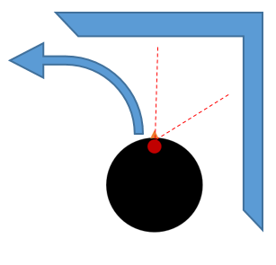
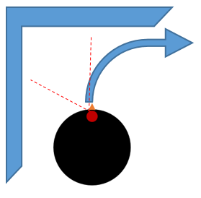
Case 2: Obstacle on right and front
Case 1: Obstacle on left and front
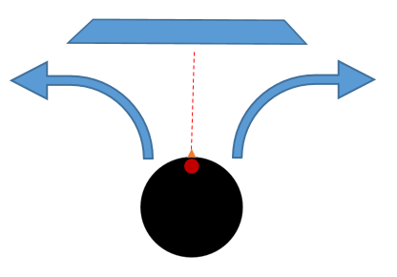
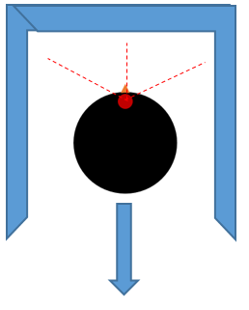
Case 3: Obstacles on all three sides
Case 4: Obstacle only on front

